Conditions of Entry
2021 63rd National Insect Salon
Nature

National Insect Salon Committee Chairman:
Joe Virbickis 424 Gillman Ave. Washington, IL 61571 USA
E-mail: Joe Virbickis.....………….... jvirbickis@gmail.com
Telephone: ..............................…(309) 635-3554

Submitting Entries: The Peoria Camera Club invites the world’s photographers to submit digital images restricted to insects, spiders, and related arthropods (such as barnacles, crabs, lobsters, shrimp, centipedes, and millipedes) for the 63rd National Insect Salon. There are no restrictions as to subject matter except as outlined in the rules and definitions. Images will be digitally projected for judging at 1400 x 1050 pixels. For judging, images will be projected with a Canon Realistic SX80 Mark II projector with maximum dimensions of 1400 pixels (horizontal) by 1050 pixels (vertical). Explanations of Image Size (1400 x 1050), File Naming conventions (35 or fewer characters, .jpg file format) and all other pertinent information is on the website. Your images show best above 500 KB but must be less than 1000 KB. The Online Entry Form with browser attached images is available for submittal at:
www.peoriacameraclub.com

63rd National Insect Salon Calendar
Closing Date October 16,2021
Judging October 23,2021
Notification Card E-Mailing November 6, 2021
Entomological Society of America, ESA in Denver Colorado, USA November 14-17, 2021
EDAS due at PSA November 22, 2021
2021 Award Mailing, by January 8, 2022
The HTML Catalog Posting on Website www.peoriacameraclub.com January 8, 2022

Please fill in the personal information and upload your images on the website. Please pay the entry fee using the Pay Pal window that opens after your entry is sent. If you prefer to send the fees by mail, use the following address: Joe Virbickis 424 Gillman Ave, Washington, IL 61571 USA. Mailed fees must be received at this address before the closing date.

Entry Fee:
$10.00(USD)
In USA Dollars or check payable to Peoria Camera Club drawn on a USA Bank. We prefer Pay Pal.
Please use the Pay Pal tab at the end of your entry process.

NOTICE: When an entrant fills in the Entry Form to submit an entry the entrant will see a feature to affirm he or she has read these Conditions of Entry when he or she fills out the entry form. If the entrant does not so affirm the entry will not be submitted

PSA Recognition Number
PSA 2012-1574

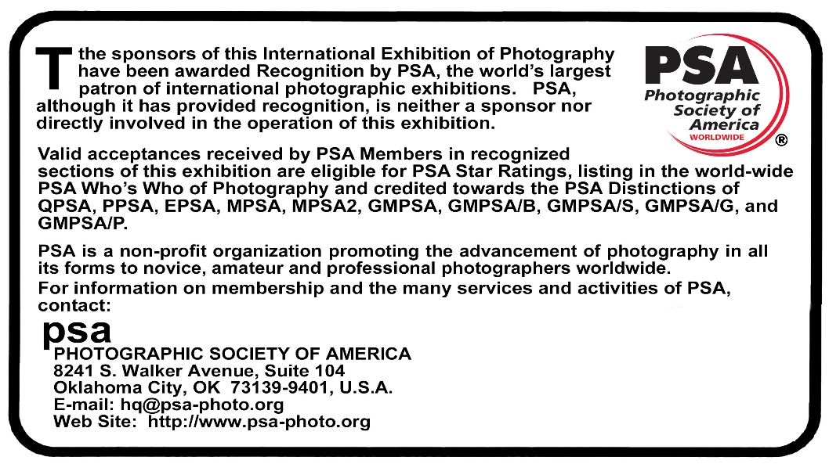

The Exhibition will be conducted in accordance with the rules of the PSA

An entrant’s images will not be presented to the judges consecutively. An entrant’s four images will be distributed throughout four rounds of judging in that section. Distribution of images will be in the same round order as submitted by the entrant.

An image may be entered in only one section where acceptances of that image in multiple sections would be eligible for the same star path.

IMAGE AND ENTRY REQUIREMENTS This exhibition is open to anyone; however, an entry may be rejected when the Sponsor or the Exhibition Organizers, in their reasonable discretion, believes the entry does not conform to exhibition rules and these Conditions of Entry. Membership in any photographic organization is not required.

Sanctions: Entries will not be accepted from any entrant who is currently sanctioned by PSA.

PSA Star Ratings
To receive proper Star ratings credit from PSA, entrants must provide their names and country exactly the same in each exhibition. Aliases are not permitted. Please contact PSA in the event of name changes or relocating to another country.

Image Creation
Entries must originate as photographs (image-captures of objects via light sensitivity) made by the entrant on photographic emulsion or acquired digitally. .
Certification:
By virtue of submitting an image, the entrant certifies the work as his or her own (Images may not incorporate elements produced by anyone else (for example: clip art, images or art by others downloaded from the Internet). Aliases are not allowed. The entrant permits the sponsors to reproduce all or part of the entered material free of charge for publication and/or display in media related to the exhibition. This may include low resolution posting on a website. Note: Entrants who indicate that their images may not be reproduced or used “will not be eligible for awards” or inclusion in audio-visuals of the exhibition “and could be subject to disqualification” by the exhibition sponsors. The exhibition assumes no liability of any misuse of copyright

Alteration and Computer Generation Subject to Divisional restrictions (particularly Nature, Photo Travel, and Photojournalism) images may be altered, either electronically or otherwise, by the maker. Adjustments to enhance images or creatively modify images are allowed providing the underlying photograph is retained in a way that is obvious to the viewer. Images may not be constructed entirely with a computer, and must be the sole work of the author

Re-use of accepted images: Once an image has been accepted in a PSA Recognized exhibition, any identical image, or near identical image, may not, in future, be entered or re-entered in any section of the same Division Star Ratings class in that exhibition regardless of media, format, or title; may not be re-titled for entry into any other PSA Recognized exhibition, including translation into another language.

Entry: An Entry consists of, up to and including, four (4) images entered by a single Entrant into the same Section. An entrant may only enter a specific Section once.

Titles:
Each image must have a unique title. That unique title must be used for entry of that image or of an Identical Image into any and all PSA-Recognized exhibitions. Titles must be 35 characters or fewer. No titles may be visible to the judges, and nothing in the image may identify the maker. Titles must not include file extensions such as .jpg or .jpeg (or any other camera capture filenames), or words such as "untitled" or "no title". Titles may not consist solely of numbers.

Color and Monochrome:
Color and Monochrome images from the same capture that share substantial pictorial content in common will be considered the same image and must be given the same title.

Judges: Pete Anderton
Veronica Anderton
Patrick Dowd
Judging Process: Judges will view projected images together at a single location. Numerical scoring (3,4,5) will used with appropriate tie-breaking procedures used as needed for final determination of Acceptances, Honors and Medals.

Awards – Nature - Digital – Insects
Best of Show (PSA Gold Medal); Peoria Camera Club (PCC) Medals: Most Unusual Image; Best Story Telling Image Best Image by an ESA Member; Best Image by a Non-ESA Member; Best Image by Peoria Camera Club Member.

PSA Statement on Subject Matter
There is one hard and fast rule, whose spirit must be observed at all times and applies to all sections offered in PSA recognised exhibitions.
The welfare of the subject is more important than the photograph.
This means that practices such as baiting of subjects with a living creature and removal of birds from nests, for the purpose of obtaining a photograph, are highly unethical, and such photographs are not allowed in any PSA exhibitions.
There is also a PSA policy on the use of aerial photography - aircraft, helicopters and drones. This policy can be found at https://psa-photo.org/index.php?psa-policies#drone.
The purpose of this policy is to prevent any interference with other individuals or animals which will or may cause a disturbance in their normal activity or disrupt the way any individuals or animals interact with their environment. Entry in this exhibition requires exhibitors to agree to this and other PSA policies
The content of images must comply with these General Conditions and with the Division and Section definitions listed in these conditions. Images that - in the sole opinion of the judges or the Exhibition Organizers - do not comply are likely to be disqualified so the entrant may be aware of the problem when considering entry into other PSA recognized exhibitions.

PSA/FIAP Nature Definition
Nature photography is restricted to the use of the photographic process to depict all branches of natural history, except anthropology and archeology, in such a fashion that a well-informed person will be able to identify the subject material and certify its honest presentation.
The story telling value of a photograph must be weighed more than the pictorial quality while maintaining high technical quality
Human elements shall not be present, except where those human elements are integral parts of the nature story such as nature subjects, like barn owls or storks, adapted to an environment modified by humans, or where those human elements are in situations depicting natural forces, like hurricanes or tidal waves.
Scientific bands, scientific tags or radio collars on wild animals are permissible.
Photographs of human created hybrid plants, cultivated plants, feral animals, domestic animals, or mounted specimens are ineligible, as is any form of manipulation that alters the truth of the photographic statement.
No techniques that add, relocate, replace, or remove pictorial elements except by cropping are permitted.
Techniques that enhance the presentation of the photograph without changing the nature story or the pictorial content, or without altering the content of the original scene, are permitted including HDR, focus stacking and dodging/burning.
Techniques that remove elements added by the camera, such as dust spots, digital noise, and film scratches, are allowed.
Stitched images are not permitted.
Color images can be converted to greyscale monochrome.
Infrared images, either direct-captures or derivations, are not allowed.
Images entered in Nature sections meeting the Nature Photography Definition above can have landscapes, geologic formations, weather phenomena, and extant organisms as the primary subject matter. This includes images taken with subjects in controlled conditions, such as zoos, game farms, botanical gardens, aquariums and any enclosure where the subjects are totally dependent on man for food.
Attention is drawn to the PSA Statement on Subject Matter which applies to all sections

Breaches of Rules
If, at any time, it is determined in the reasonable discretion of the exhibition organizer or the judges before, during, or after the judging of an exhibition that an entrant has submitted entries where one or more images may fail to comply with these Conditions of Entry, including the stated definitions, the exhibition organizers reserve the right to delete the entry from the exhibition and void any or all acceptances or awards in connection with the exhibition. Fees may be forfeited or refunded in these circumstances. The entrant acknowledges that the decision of the exhibition organizers or the judges is final
In order to ensure that images comply with the Conditions of Entry and definitions, the exhibition organizers may carry out reasonable measures to verify that:
a) the images are the original work of the entrant and
b) the images comply with the rules and definitions as set out in these Conditions of Entry
These steps include, but are not limited to, questioning any entrant, requiring the submission of RAW files or other digital files representing the original capture of the submitted image(s), confronting the entrant with evidence that one or more submitted images fails to comply with the Conditions of Entry (also known as Entry Rules), and offering the entrant a reasonable opportunity to provide counter evidence to refute the exhibition organizer’s evidence by a set deadline. Such entries that are not cleared or are still questionable after the entrant has presented evidence may be considered in breach of these Conditions of Entry, and declined. Such entries may be referred to PSA for further investigation of possible ethics violations
PSA retains the right to investigate in any way all complaints/suspicions of breaches of entry conditions, impose sanctions if deemed necessary, void the acceptances of any image found to violate the PSA rules, include the entrant’s name on the list of sanctions provided to Exhibitions, and share such investigations with FIAP. Entrants automatically agree to these terms by the act of entering the Exhibition and agree to cooperate with any investigation.
If another party is submitting images on the entrant’s behalf, the entrant will still be held responsible for adhering to these Conditions of Entry (Entry Rules) and will be subject to sanction for any violations to these Conditions of Entry and PSA’s Statement of Ethics that may result.

DATA PROTECTION
By entering this exhibition, you are explicitly consenting to the personal details you have supplied, including email addresses, being held, processed and used by the exhibition organizers for purposes associated with this exhibition. You also explicitly consent to such information being sent to organizations that have accorded official recognition, patronage or accreditation to this exhibition. You acknowledge and accept that entering this exhibition means that the status and results of your entry may be made public.
.

