Conditions of Entry
2019 62nd National Insect Salon
Nature
National Insect Salon Committee Chairman:
Joe Virbickis 424 Gillman Ave. Washington, IL 61571 USA
E-mail: Joe Virbickis.....………….... jvirbickis@gmail.com
Telephone: ..............................……………... (309) 635-3554

Submitting Entries: The Peoria Camera Club invites the world’s photographers to submit digital images restricted to insects, spiders, and related arthropods (such as barnacles, crabs, lobsters, shrimp, centipedes and millipedes) for the 62nd National Insect Salon. There are no restrictions as to subject matter except as outlined in the rules and definitions. Images will be digitally projected for judging at 1400 x 1050 pixels. For judging, images will be projected with a Canon Realistic SX80 Mark II projector with maximum dimensions of 1400 pixels (horizontal) by 1050 pixels (vertical). Explanations of Image Size (1400 x 1050), File Naming conventions, and all other pertinent information is on the website. Your images show best above 500 KB but must be less than 1000 KB. The Online Entry Form with browser attached images is available for submittal at:
www.peoriacameraclub.com

Please fill in the personal information and upload your images on the website. Please pay the entry fee using the Pay Pal window that opens after your entry is sent. If you prefer to send the fees by mail use the following address.

NOTICE: When an entrant fills in the Entry Form to submit an entry the entrant will see a feature to affirm that he or she has read these Conditions of Entry when he or she fills out the entry form. If the entrant does not so affirm the entry will not be submitted.

Entry Fee:
$10.00 ($USD) Any fees sent by mail must arrive before the closing date to:
Joe Virbickis 424 Gillman Ave. Washington, IL 61571 USA
In USA Dollars or check payable to Peoria Camera Club drawn on a USA Bank. We prefer Pay Pal.
Please use the Pay Pal tab at the end of your entry process.

PSA Recognition Number
PSA 2019-427

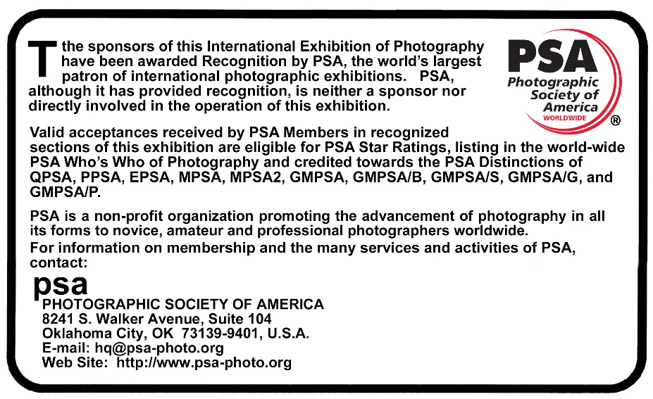

Judges: To be announced

Note: The entrant may enter one digital section (Nature) for PSA stars. Entries may consist of 4 images uploaded on the website OR 2 or 3 images on the website plus 1 or 2 sequences for a total of 4 entries.

Sequences:
Sequences will follow the same rules except they must be submitted by mail on Compact Disk or E-Mail. The sequence entries must be 1400 by 1050 pixel jpg images, not more than 1000kb in size each, from 2 to 10 images with a narrative not exceeding 400 words. Mail your CD to Joe Virbickis 424 Gillman Ave. Washington, IL 61571 USA.
Or e-mail to jvirbickis@gmail.com Be sure to mail in time to arrive before the closing date including your name, address, and e-mail address. The CD’s will be destroyed after the exhibitions.

Awards – Nature - Digital – Insects
Best of Show (PSA Gold Medal); Most Unusual Image (Central Illinois Camera Club Association Medal); Best Story Telling Image (Peoria Camera Club Medal); Best Image by an ESA Member (Special ESA Award of Excellence Medal); Best Image by a Non-ESA Member (Special ESA Award of Excellence Medal); Best Image by Peoria Camera Club Member; Best of Show Sequence; and Honorable Mentions.

Conditions
The exhibition is open to anyone; however, an entry may be rejected when the sponsoring organization or its agent, in its reasonable discretion, believes the entry does not conform to the exhibition rules and conditions.

An entrant’s images will not be presented to the judges consecutively. An entrant’s four images will be distributed throughout four rounds of judging in that section. Distribution of images shall be in the same
round order as submitted by the entrant.

Entries must originate as photographs (image-captures of objects via light sensitivity) made by the entrant on photographic emulsion or acquired digitally. By virtue of submitting an entry, the entrant certifies the work as his own (aliases are not permitted). The entrant permits the sponsors to reproduce all or part of the entered material free of charge for publication and/or display in media related to the exhibition. This may include low resolution posting on a website. Note: Entrants who indicate that their images may not be reproduced or used “will not be eligible for awards” or inclusion in audio-visuals of the exhibition “and could be subject to
disqualification” by the exhibition sponsors. The exhibition assumes no liability of any misuse of copyright. Images may be altered, either electronically or otherwise, by the maker. Artwork or computer
graphics created by the entrant may be incorporated provided the photographic content predominates, subject to Nature, Photo Travel and Photojournalism divisional restrictions. All final work must be on photographic film, or on electronic file, or on photographic or electronic print material, mounting excepted.

No title or identification of the maker shall be visible anywhere on the face of an image, print mat or mount entered in a PSA Recognized exhibition. Each image must have a unique title. Once an image has been accepted in a PSA Recognized exhibition, that same image, or a like “in camera” or a “reproduction”
duplicate of that image:
1. May not be entered or re-entered in any section of the same Division Star Ratings class in that exhibition regardless of media, format, or title.
2. May not be re-titled for entry in any other PSA Recognized exhibition, including translation into another language.
3. Images meeting the Monochrome Definition and non-manipulated color images from the same capture
shall be considered the same image and must be given the same title.
4. PSA members working on Galaxy and Diamond Star Ratings shall be allowed to continue using different titles of monochrome versions and color versions of the same capture that have already been accepted until the required number of acceptances for those titles have been completed.

Words such as “Untitled” and “No Title” are not acceptable as part or all of an image’s title, nor are camera capture filenames.

PSA Rules – Nature Division
Nature photography is restricted to the use of the photographic process to depict all branches of natural history, except anthropology and archeology, in such a fashion that a well-informed person will be able to identify the subject material and certify its honest presentation.
• The story telling value of a photograph must be weighed more than the pictorial quality while maintaining high technical quality.
• Human elements shall not be present, except where those human elements are integral parts of the nature story such as nature subjects, like barn owls or storks, adapted to an environment modified by humans, or where those human elements are in situations depicting natural forces, like hurricanes or tidal waves.
• Scientific bands, scientific tags or radio collars on wild animals are permissible.
• Photographs of human created hybrid plants, cultivated plants, feral animals, domestic animals, or mounted specimens are ineligible, as is any form of manipulation that alters the truth of the photographic statement.
• No techniques that add, relocate, replace, or remove pictorial elements except by cropping are permitted.
• Techniques that enhance the presentation of the photograph without changing the nature story or the pictorial content, or without altering the content of the original scene, are permitted including HDR, focus stacking and dodging/burning.
• Techniques that remove elements added by the camera, such as dust spots, digital noise, and film scratches, are allowed.
• Stitched images are not permitted.
• All allowed adjustments must appear natural.
• Color images can be converted to greyscale monochrome.
• Infrared images, either direct-captures or derivations, are not allowed.
• Images entered in Nature sections meeting the Nature Photography Definition above can have landscapes, geologic formations, weather phenomena, and extant organisms as the primary subject matter. This includes images taken with subjects in controlled conditions, such as zoos, game farms, botanical gardens, aquariums and any enclosure where the subjects are totally dependent on man for food.

BREACH OF CONDITIONS OF ENTRY
If at any time, it is determined in the reasonable discretion of the exhibition organizer or the judges before, during, or after the judging of an exhibition that an entrant has submitted entries where one or more images may fail to comply with these Conditions of Entry, including the stated definitions, the exhibition organizers reserve the right to delete the entry from the exhibition and void any or all acceptances or awards in connection with the exhibition. Fees may be forfeited or refunded in these circumstances. The entrant acknowledges that the decision of the exhibition organizers or the judges is final.
In order to ensure that images comply with the Conditions of Entry and definitions, the exhibition organizers may carry out reasonable measures to verify that:
a) the images are the original work of the entrant and
b) the images comply with the rules and definitions as set out in these Conditions of Entry.
These steps include, but are not limited to, questioning any entrant, requiring the submission of RAW files or other digital files representing the original capture of the submitted image(s), confronting the entrant with evidence that one or more submitted images fails to comply with the Conditions of Entry (also known as Entry Rules), and offering the entrant a reasonable opportunity to provide counter evidence to refute the exhibition organizer’s evidence by a set deadline. Such entries that are not cleared or are still questionable after the entrant has presented evidence may be considered in breach of these Conditions of Entry and declined. Such entries may be referred to PSA for further investigation of possible ethics violations.
PSA retains the right to investigate in any way all complaints/suspicions of breaches of entry conditions, impose sanctions if deemed necessary, void the acceptances of any image found to violate the PSA rules, include the entrant’s name on the list of sanctions provided to Exhibitions, and share such investigations with FIAP. Entrants automatically agree to these terms by the act of entering the Exhibition and agree to cooperate with any investigation.

DATA PROTECTION
By entering this exhibition, you are explicitly consenting to the personal details you have supplied, including email addresses, being held, processed and used by the exhibition organizers for purposes associated with this exhibition.
You also explicitly consent to such information being sent to organizations that have accorded official recognition, patronage or accreditation to this exhibition. You acknowledge and accept that entering this exhibition means that the status and results of your entry may be made public.

62nd National Insect Salon Calendar: A list of all the entries received and status of entry fee will be published on the Salon Web Site and updated monthly. Please check the status of your image entries and payments on the Web Site about a month after sending so they can be resent if necessary.
Closing Date.................................………………………………………………….…...…..........October 5, 2019
Judging ....................................……………………………...…………………….....……….......October 12, 2019
Notification Card E-Mailing ......………....……………………………………………….……...October 26, 2019
Entomology 2019 (Entomological Society of America) in St. Louis, Missouri USA …………...November 17-20, 2019
2019 Award Mailing.........…...…..…….………………………………………………….……...December 28, 2019
The HTML Catalog Posting on Website www.peoriacameraclub.com...………………………...December 28, 2019

